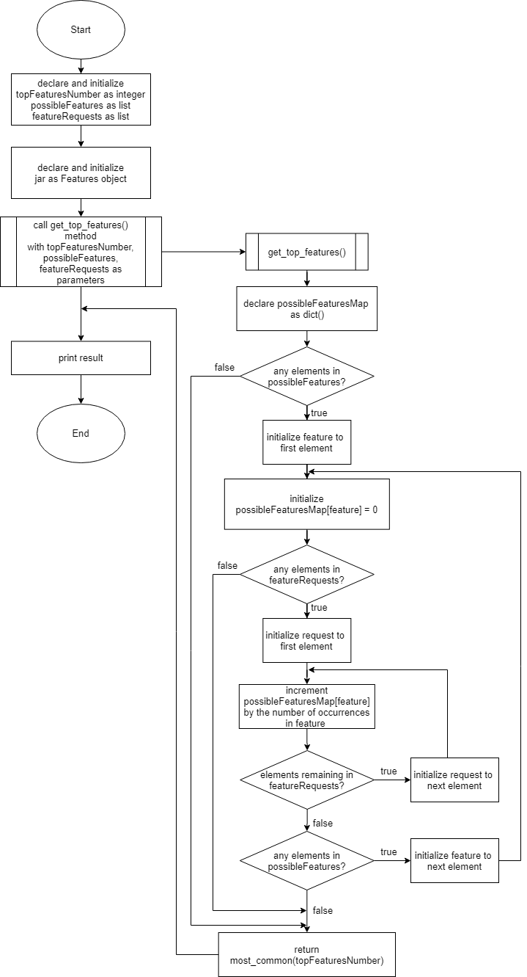

**Figure**: Flowchart Task 2